**Create a Cardboard Character for World Book Day.**

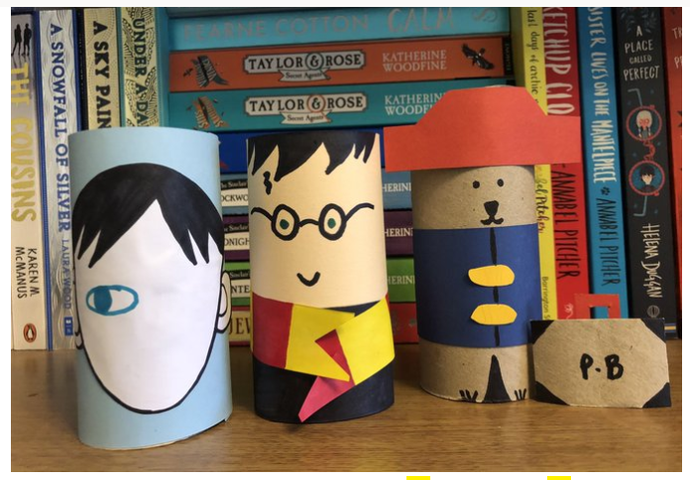

If you have a spare cardboard tube or two lying around and some coloured pens or pencils, why not try to create your favourite book character! You could make a whole book-full of characters: Mr Stink, Chloe and her parents, George and his Grandma for George’s marvellous medicine, The Weasleys…. Bring your cardboard characters into school with you next week and we’ll add them to our Reading display!